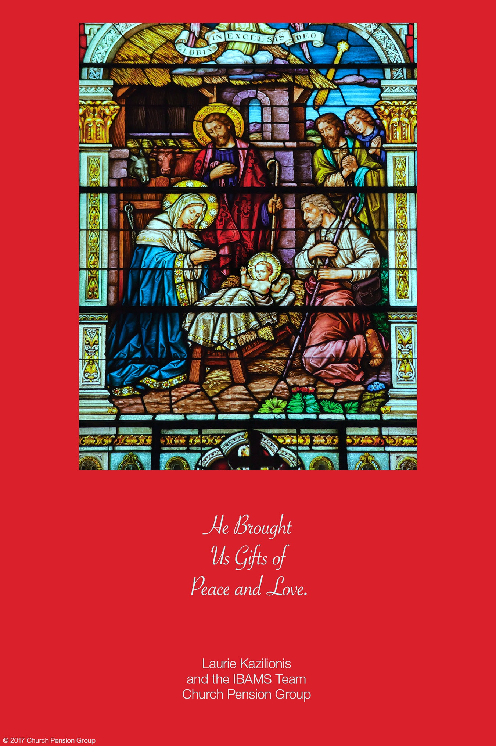
11
ST MICHAEL & ALL ANGELS
EPISCOPAL CHURCH
Ministers of the Church
The People of St. Michael
Our Vestry & Staff
Neil James, Senior Warden
850-321-4978
Charlie Clark, Junior Warden
850-631-0780
Akachi Anwuri
Delois Brown
Linda Dilworth
Ama Erefah
Dawn Freeman
Propok Hruda
Sharal Jugger
Alexis Roberts McMillan
Sam Oliver
Edith Onyeozili
Laureatte Scott, Treasurer/Vestry Clerk
Kathleen Rodgers, Financial Secretary
Monique Alleyne and Ivana Kenny Carmola
Organists
Chris White, Drummer/Choral Director
Sam Oliver, Verger
Elizabeth Humes, Admin. Assistant
James Crowell, Sexton Emeritus
Our Clergy
The Right Reverend John Howard
Bishop – Diocese of Florida
The Reverend Hugh Chapman, Rector
340-513-1123
Frhugh_chappy63@yahoo.com

Monday, December 24, 2018
Christmas Eve Eucharist
10:00 pm

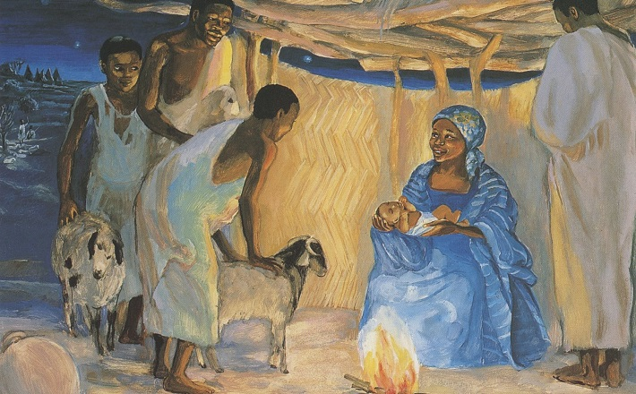

1405 Melvin St, Tallahassee, FL 32301
Phone: (850) 681-0844
Office Hours: Monday to Friday
8:00 am – 4:00 pm
Email: office@stmichaelandallangels.org
Website: www.stmichaelandallangels.org
Find us on Facebook as well!
Follow us on Twitter @SMAA_Tally

ONE SOLITARY LIFE
He was born in an obscure village, the child of a peasant woman. He grew up in still another village, where He worked in a carpenter shop until He was thirty. Then for three years He was an itinerant preacher. He never wrote a book. He never held an office. He never had a family or owned a house. He didn’t go to college. He never visited a big city.

He never traveled more that two hundred miles from the place where He was born. He did none of the things one usually associates with greatness. He had no credentials but Himself. He was only thirty-three when the tide of public opinion turned against him. His friends ran away.

He was turned over to His enemies and went through the mockery of a trial. He was nailed to a cross between two thieves. While He was dying, His executioners gambled for His clothing, the only property He had on earth. After He died, He was laid in a borrowed grave through the pity of a friend.

Nineteen centuries have come and gone, and today He is the central figure of the human race and the leader of mankind’s progress. All the armies that ever marched, all the navies that ever sailed. All the parliaments that ever sat, all the kings that ever reigned, put together, have not affected the life of man on this earth as much as that one solitary life.

THE MANY MEANINGS OF CHRISTMAS
Christmas is the glow that warms the hearts of people wherever the message of “peace on earth to men of goodwill” is believed.
Christmas is peace in a world where people have been alienated from each other by hatred and jealousy.
Christmas is love that flows from one heart to another.
Christmas is giving, sharing, lifting, caring, and being what Christ wants us to be.
Christmas is giving to those who cannot give to us. It is visiting the neglected, lifting the fallen, giving hope to the hopeless, assuring victory to the defeated.
Christmas is surrender of one’s life to Christ in renewed dedication, making Christ the Lord of our lives.
1
Suggested daily Readings for the week of the Fourth of Advent Dec 24– Dec.28
Mon. Isa. 8:16 – 9:1 Psalm 44 2 Pet. 1:1-11
Tue. Isa. 9:1-7 Psalm 47, 48 2 Pet. 1:12-21
Wed. Isa. 9:8-17 Psalm 49, (53) 2 Pet. 2:1-10a
Thurs. Isa. 9:18 –10:4 Psalm 59, 60 2 Pet. 2:10b-16
Fri. Isa. 10:5-19 Psalm 51 2 Pet. 2:17-22
Sat. Isa. 10:20-17 Psalm 138,139:1-17 Jude 17-25

Summer Camp 2019 Dates and Fees
Session | Ages | Dates | Cost
Mini Camp: Disney | 6-10 | June 13-16 | $315
Senior Session: Color Wars | 15-18 | June 16-22 | $560
Session 1: Superheroes | 7-14 | June 23-29 | $560
Session 2: Outer Space | 7-14 | July 7-13 | $560
Session 3: Harry Potter | 7-14 | July 14-20 | $560
Session 4: Around the World | 7-14 | July 21-27 | $560
Stayover 1 | 7-14 | July 13-14 | $75
Stayover 2 | 7-14 | July 20-21 | $75

Register by January 1st to get Early Bird pricing! Senior Session and Sessions 1, 2, 3, and 4 will be $540 before January 1. Mini Camp will be $300 before this deadline.
Scholarship applications are due April 15. Please contact Allison Vining at allison@campweed.org (386-364-5250.

YOU CAN KEEP CHRISTMAS
Are you willing to believe that love is the strongest thing in the world – stronger that hate, stronger than evil, stronger than death – and that the blessed life which began in Bethlehem two thousand years ago is the image and brightness of the eternal love? Then you can keep Christmas.

10
UPCOMING EVENTS
Happening #139 (January 18-20, 2019)
Happening is a renewal weekend for high school aged young people. The purpose of Happening is to renew the spiritual life of high schoolers who attend so that they may take their places in the ministry and leadership of the parishes and missions that sponsor them.
The Episcopal Church Women Nominating Committee announces the following persons who were invited to serve as the new officers for 2019: President—Dawn Dawson-Freeman, Vice President—Herma Watson-Taylor, Financial Secretary—Delois Brown, and Secretary (Recording)—Nicolette Nottage. These officers will assume office effective January 1, 2019 for a term of one year. All women of St. Michael’s are also encouraged to become active in the ECW’s three committees: In-Reach, Out-Reach and Fund Raising.

ECW: Mark your calendars! The Episcopal Church Women of the Diocese of Florida invite you to attend the ECW Winter Meeting, which will be on February 16, 2019 at Camp Weed. The guest speaker is The Rev. Canon Dr. Allison Defoor, Canon to the Ordinary. Check-in starts at 9:00 am and the meeting at 10:00 am. We will conclude with lunch in the Varn Dining Hall at noon.
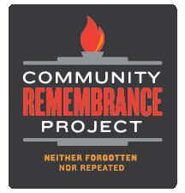
On Saturday January 12 at 10:00 a.m, St. Michael and All Angels Episcopal Church will host an informative meeting concerning the Tallahassee Community Remembrance Project, an effort to remember four African-American men who were lynched in Leon County between 1897 and 1937. The discussion will be facilitated by Evan Milligan, a member of the Equal Justice Initiative's Memorial Monument Placement Initiative Team in Montgomery, Alabama. Mr. Milligan works closely with the Race and Poverty Initiative and assists with public education, community outreach, and research efforts around EJI's Community Remembrance Projects.
To RSVP, please email office@saintmichaelandallangels.org or call 850-681-0844.
Please invite your friends. All are welcome!
9
CHRISTMAS CAROLS
H103 The first noel
H89 It came upon the midnight clear
H110 The snow lay on the ground
H79 O little town of Bethlehem
H101 Away in a manger
H112 In the bleak midwinter
H128 We three kings
H115 What child is this?
Acolytes light the middle candle, the church lights are lowered more, and the acolytes will take the light from the Christ candle and light the candle of the persons closest to center aisle, who will then pass the light to people in their pew row.
THE LIGHT OF CHRIST
In gratitude for the One announced by the light of stars and angels, we light the Christ candle. Hear the word of the Lord: “The people walking in darkness have seen a great light; on those living in the land of the shadow of death, a light has dawned.” For the Light of Christ that shines in the darkness for all people in all times, we give thanks.

Go now and share the good news of the gospel of peace: I have come to comfort those who mourn, to give them joy instead of sorrow, hope instead of despair. My unfailing love will not be shaken; my promise of peace stands forever. I have come into the world as a light, so that no one who believes in Me should stay in darkness.

For God, who said “Let light shine out of darkness,” has made His light shine in your hearts. No one lights a lamp and hides it. Instead, he puts in on a stand, so that those who enter may see the light. In the same way, let your light shine. You are the light of the world. Go now as children of light.

2
HOLY EUCHARIST- RITE TWO
Instrumental Prelude Debralee LaSeur, organist
Adesh Balraj, trumpet

Processional Hymn H83, O come All Ye Faithful Adeste fideles
THE WORD OF GOD
Opening Acclamation 355
The Collect for Purity
Gloria L243 Haywood
Collect for the Day
The Lessons Isaiah 9:2-7
Psalm 96
Titus 2:11-14
Gradual Hymn H96 v 1-2, Angels we have heard on high Gloria
The Holy Gospel Luke 2:1-14 The Reverend Hugh Chapman
Sequence Hymn H96 v 3-4 Gloria
The Sermon The Reverend Hugh Chapman
The Nicene Creed 358
The Prayers of the People VI 392
Confession of Sin and Absolution 360
The Peace H111, Silent Night Stille Nacht
Offertory Selection
Doxology & Procession H380, Praise God from Whom all Blessing Flow Old 100th
3
ANNOUNCEMENTS
December 27 – Feast of St. John Apostle at 12:15 pm.
December 28 – Feast of Holy Innocents at 10:100 am.
There will be no service on December 31 BUT JANUARY 1 AT 12 noon.
January 2 – First Wednesday Supper at the Kearney Center located off W. Pensacola Street at 2650 Municipal Way at 6:30 pm. Please wear closed toe shoes and a hat or cap.
January 3 – Said Mass at 12:15 p.m.
January 6 – Capital Campaign Meeting following Eucharist Service in the Parish Hall.
January 6 – Discipleship Group Meeting at 4:00 pm in the Brooks Room.
January 8 – Clergy Meeting at Grace Mission at 12:30 pm.
January 10 – Said Mass at 12:15 am. (Contemplative Eucharist)
January 12 – Remembrance Project Gathering at 10:00 am in the Parish Hall.
January 14 – Vestry Meeting from 6:00 pm – 7:30 pm in the Brooks Room.
SPIRITUAL DEVELOPMENT – Bible Study Class is now in recess.
GOOD NEWS OUTREACH MINISTRY –. The Area Agency on Aging is asking for donations to help seniors affected by Hurricane Michael. They are in need of adult incontinent supplies - disposable pads, baby wipes, rash guard cream/ointment, nutrition drinks such as Boost and Ensure, flashlights/batteries, water, hygiene products, towels, etc. Many communities may not have power for many weeks or longer so non-perishables of any sort are welcome. Good News Outreach will be collecting items at the administrative office 347 Office Plaza Drive for Area Agency on Aging. Thank you in advance for any assistance.

CHOIR NEWS – There will be rehearsal every Sunday morning at 9:15 am until further notice.
8
PRAYER REQUESTS FOR PEACE AND HEALING:
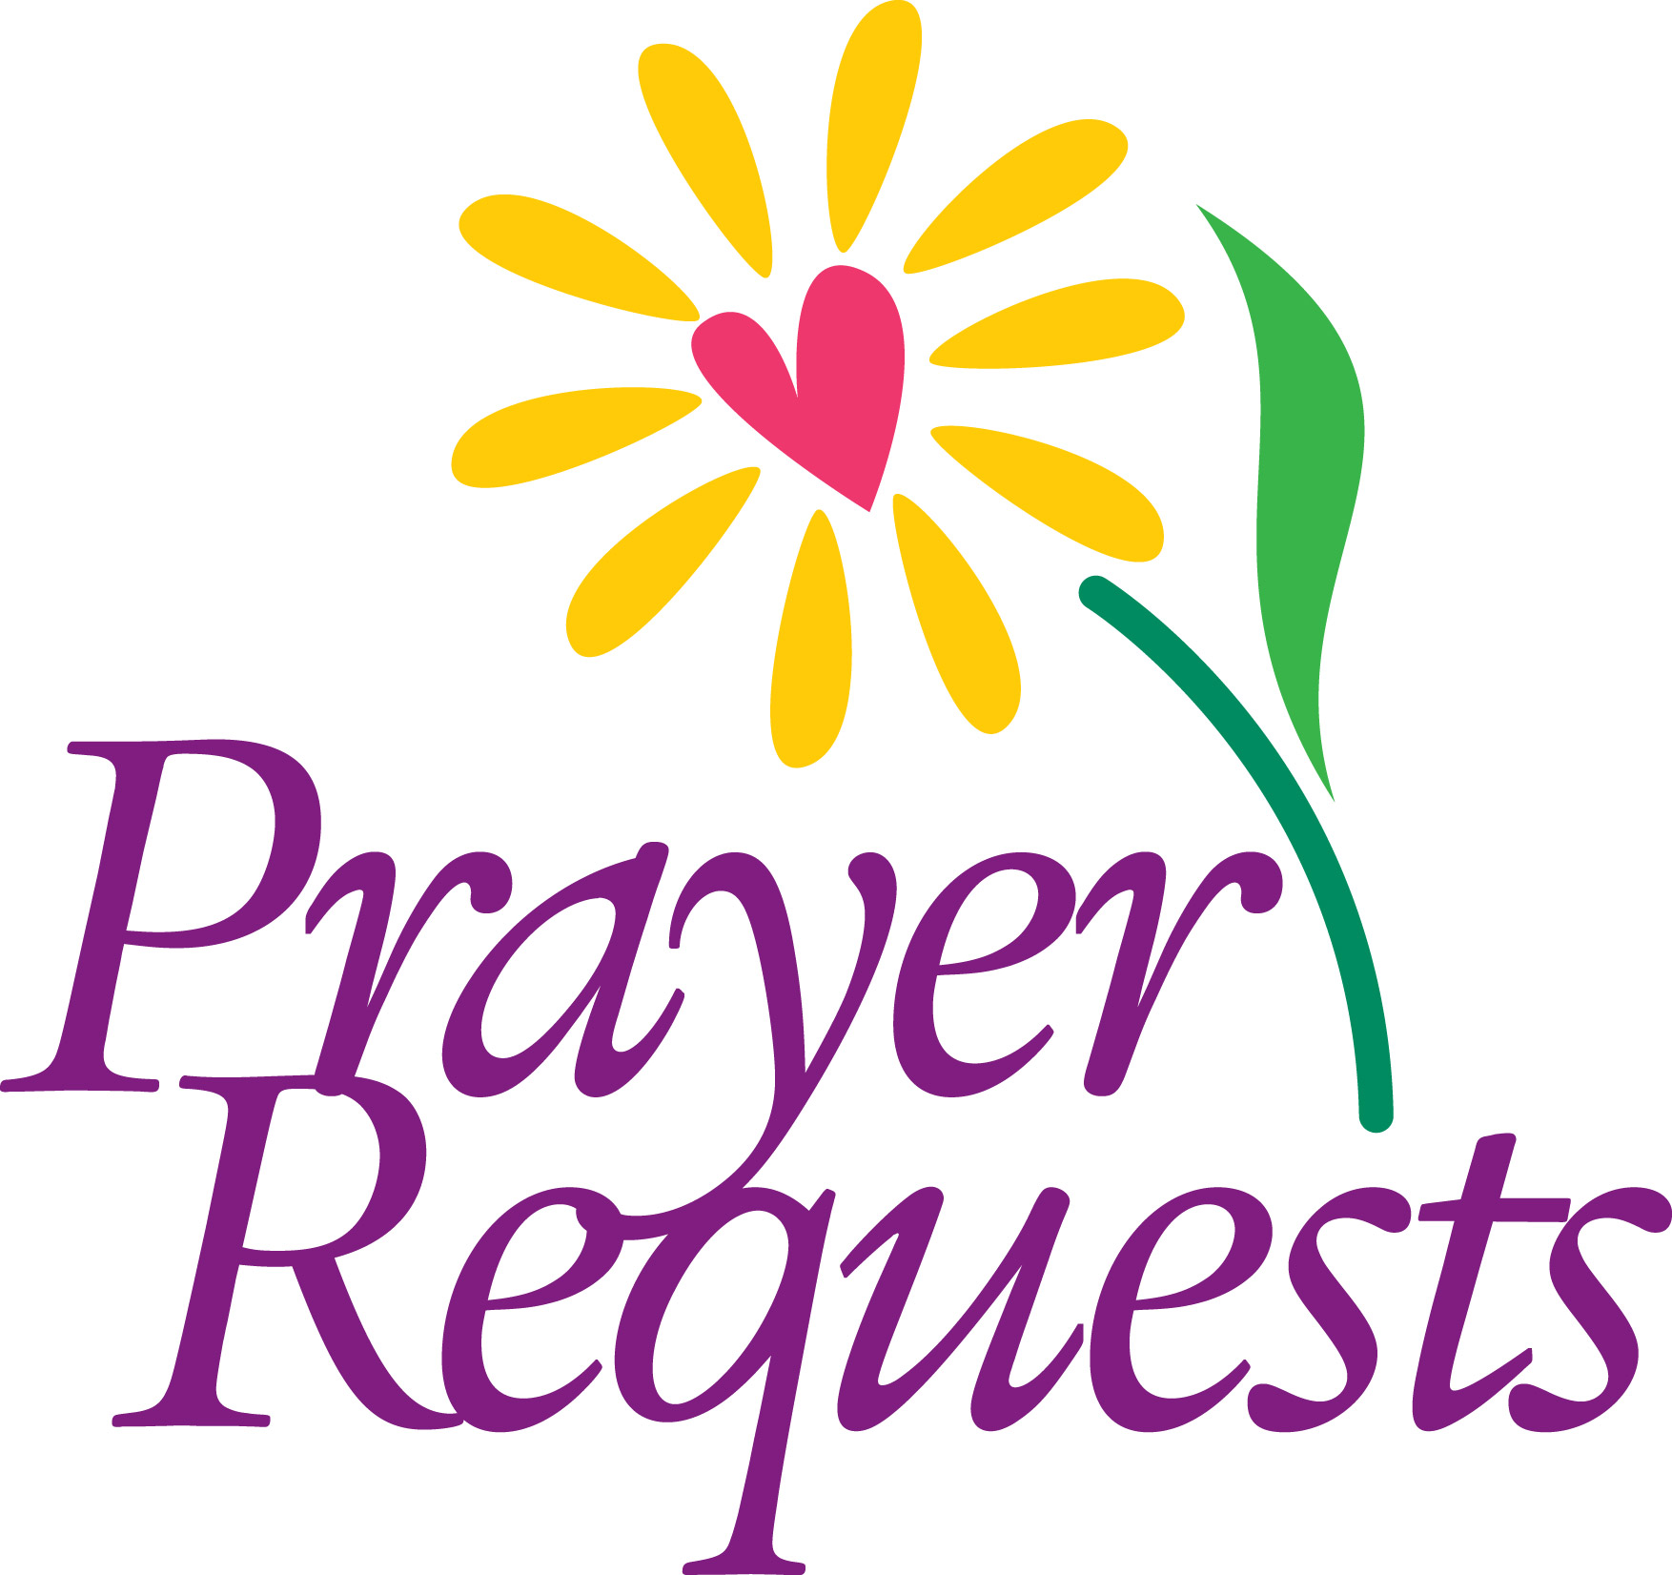
Jean Hyche-Jackson, Jo Ann Robinson, Ophelia and Robert Scarbough, Eugene Wesley, Rosalyn Greene, Rose Douglas, Jewell Robinson, Williemae Jackson, Geraldine Roberts, Joseph Wiley, Carl Murray, Rudolph Hinds, Cynthia Hinds, Alexes Parker, Robert Roulac, Karen Hardy Clark, Ella Woodbury, Charles Daniels, Joseph Gentle, Brandi Leland, Kenrick Baynes, Jessie Laurel, Hattie Olivia Scott, Rev. Canon Dr. David J. Weidner, Ella Brown Albright, Catherine Rand, Richard Corpening, Clifford Willabus, Mecie White, Barbara Lee, Sharon Carr, Sam Oliver Sr., Linzie Bogan II, Clark Bogan, Dr. Derek Spencer, Ariel Boyd, Lora Rose Hunter-Dargan, Thelma Hilliard, John McClees, Jonecia Brown, Louis Chapman, Toni Jarmon, Kaleb Way ,Karen Padmore, Charles Bennett, Randolph Frazier Jr., Nohemy Reid, Kanesha Cole, Sharon Thomas, Evelyn McKetty and Maryann Nottage.

SPECIAL PRAYERS
Father, you have made all people with eyes to see you at work in the world, ears to hear you cry out when right suffers wrong, when justice is brought low. Give to the people of
our nation courage to stand up for goodness and right-doing in the face of an oppressive spirit, and courage to believe that we may restore, in accordance with your gracious will, a light to enlighten the nations and the people with your truth; through Jesus Christ our Lord, who lives and reigns with you and the Holy Spirit, one God, for ever and ever. Amen.

Capital Campaign Prayer
Most gracious Lord Jesus Christ and generous source of all abundance, in gratitude we invite you to expand our hearts as we seek to increase and improve this place of worship, peace, healing, forgiveness, outreach, service and fellowship. May all who enter here be restored and strengthened on their journey of faith. Guide us Heavenly Father, that we may make manifest your vision of a beloved and enlightened church and community, and be a shining example of the living presence of the Holy Spirit. May we and our Capital Campaign be a channel of God’s abundant grace. Through Jesus Christ our Lord we pray. Amen.

7
Presentation of the Offering – prayer to be said
Father, we offer you these gifts which you have given us; this bread, this wine, this money. With them we offer ourselves, our lives, and our work, to become through your Holy Spirit, a reasonable, holy and lively sacrifice. As this bread and wine become the Body and Blood of Christ, so may we and all your people become channels of your love; through the same Christ our Lord. Amen.
Presentation Hymn H99, Go Tell it on the Mountain Spiritual
The Great Thanksgiving 361-363
Sanctus L252, Holy, Holy, Holy McLin
The Lord’s Prayer L264, Lord’s Prayer Malotte
The Breaking of the Break/Fraction 364
The Invitation
Holy Communion
Communion Hymn 1 H102, Once in royal David’s city Irby
Communion Hymn 2 H84, Love came down at Christmas Gartan
Meditation Hymn H107, Good Christian friends, rejoice In dulci jubilo
Post Communion Prayer 365
Birthday, Anniversary, Travel Prayers
Announcements
Benediction
Recessional Hymn H87, Hark the herald angels sing Mendelssohn
Choral Postlude H101, Away in a manger Cradle Song
Organ Postlude

H=1982 Hymnal (blue)
L= Lift Every Voice & Sing (black, green, red)
4
WELCOME TO ST. MICHAEL

We extend a warm welcome to our guests. Thank you for worshipping with us today. If you are without a church home, we invite you to join our church family. Please sign the guest register, include your home address, phone number and, if you would like to receive the monthly newsletter, news of special events and other happenings, please also add your e-mail address.
OUR VISION is to be a cornerstone for serving the spiritual needs of the greater Tallahassee community, extending an eternal invitation to join our caring parish and to enrich the spiritual life of all people as we journey with Christ.
OUR MISSION is to experience the Gospel of Jesus Christ by feeding the mind, body and spirit of our community in fellowship and service.
HOLY COMMUNION: All baptized Christians are encouraged to receive the real and living presence of Christ in Holy Communion. To receive the Bread, extend your hands upward, palms crossed. When receiving the Wine, please guide the chalice as it is offered. If you prefer, you may leave the Bread on your palm for the person administering the chalice to dip into the Wine and place on your tongue. All persons are welcome to give thanks for God’s blessings at the altar rail, simply crossing your arms at the wrist with fingertips extending upward towards your shoulders.
HAPPY BIRTHDAY/ANNIVERSARY TO OUR CHURCH FAMILY!
Natalie Payne (12/24), Verona Satchell (12/25), Zollie White (12/27),
Birthday Prayer
Watch over thy children, O Lord, as their days increase; bless and guide them wherever they may be. Strengthen them when they stand; comfort them when discouraged or sorrowful; raise them up if they fall; and in their hearts may thy peace, which passeth understanding, abide all the days of their lives; through Jesus Christ our Lord. Amen.
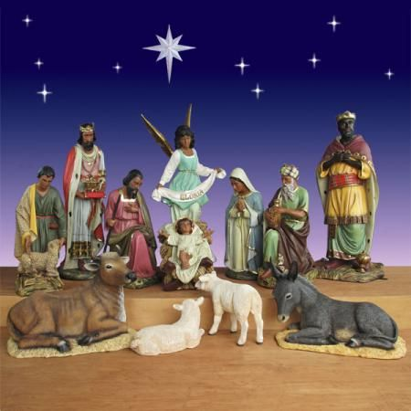
5
Serving today, December 24 at 10:00 pm
Acolytes: Chalice Bearers: Laureatte Scott, Alexis McMillan
Hollis Sams, Crucifer Lectors: Joseph Sams, Alexis McMillan
Tyler Sams, Torch Bearer Greeters: Linda Billups, Lauren Sapp
Daniel Erefah, Torch Bearer Ushers: Joseph Sams, Nadira Sams
Abigail Erefah Gospel Book Bearer Vestry: Charlie Clark
Organist: Debralee LaSeur-Helfand

Serving next Sunday, December 30 at 10:00 am
Acolytes: Chalice Bearers: Zollie White II, John Grayson
Charles Hruda , Crucifer Lectors: Renee Frazier
Quinton Laurie, Torch Bearer Greeters: Delanie McGinnis, Edward Ornstein
Collin Laurie, Torch Bearer Ushers: Byron Greene, Pamela Greene
Omar Mongerie, Gospel Book Bearer Vestry: Delois Brown
Organist: Debralee LaSeur-Helfand

NOTE: If you are unable to serve on the Sundays assigned, please ask someone else to serve in your place.
December Altar Guild:
Dawn Freeman Tangy Williams Melanie Martin
Kate Wasson Natalie Payne Pamela Greene
Jo Ann Robinson Delores Lawson
Karen Goodlett Cassandra Grayson Lauren Sapp
Delois Brown Shonna Laurie Delores Grayson
Anna White
6

