UPCOMING EVENTS
November 25 – Capital Campaign Committee meeting following worship services.
November 26 – Capital Campaign Evening Prayer from 7:00 – 7:30 pm.
November 27 – Said Mass at 12:15 pm.
November 27 – Fourth Tuesday Dinner Service at Grace Mission from 5-7:15 pm. Please be there no later than 5:00 pm. We need five individuals. Call Dawn Freeman at 850-509-2656 to sign up.
November 29 – Said Mass at 12:15 pm.

Suggested daily Readings for the Twenty-Fourth Week after Pentecost: Nov. 19 to Nov. 24
Ministers of the Church
The People of St. Michael
Our Vestry & Staff
Neil James, Senior Warden
850-321-4978
Charlie Clark, Junior Warden
850-631-0780
Akachi Anwuri
Delois Brown
Linda Dilworth
Ama Erefah
Dawn Freeman
Prokop Hruda
Sharal Jugger
Alexis Roberts McMillan
Sam Oliver
Edith Onyeozili
Laureatte Scott, Treasurer/Vestry Clerk
Kathleen Rodgers, Financial Secretary
Monique Alleyne and Ivana Kenny Carmola
Organists
Chris White, Drummer/Choral Director
Sam Oliver, Verger
Elizabeth Humes, Admin. Assistant
James Crowell, Sexton Emeritus
Our Clergy
The Right Reverend John Howard
Bishop – Diocese of Florida
The Reverend Hugh Chapman, Rector
340-513-1123
Frhugh_chappy63@yahoo.com

Mon. 1 Macc. 1:1-15, 54-57 Psalm 79 Luke 18:35-43
Tue. 1 Macc. 6:18-31 Psalm 3 Luke 9:1-10
Wed. 2 Macc. 7:1, 20-31 Psalm 17:1-8 Luke 19:11-28
Thurs. 1 Macc. 2:15-29 Psalm 129 Luke 19:41-44
Fri. 1 Macc.4:36-37, 52-59 Psalm 113 Luke 19:45-48
Sat. 1 Macc. 6:1-13 Psalm 124 Luke 20:27-40
Please note that every third Sunday the open collection will go towards the Rector’s Discretionary Fund.
The Kearney Center is asking for kind donations of Coffee, Coffee Creamer, Sugar, Grits, Oatmeal, and Seasonings, Salt and Pepper. These items are always needed.
ECW UTO Committee thanks you for sharing a portion of God's gifts to you in our UTO Fall Ingathering offerings. Your gifts will help support God's missions throughout the world and will change many lives in very real ways through various programs and projects. Thank you
SUNDAY SCHOOL is at 9:00 a.m. every Sunday. Please join us in the Parish Hall. Breakfast will be served. The Men of the Church will be sponsoring a light breakfast.

CAMP WEED
Registration is open now for Happening #139 (10-12th grades) and Breakout (4-6th grades). Happening #139 will take place January 18-20, and Breakout will take place March 9-10. Both are held at Camp Weed. Applications are open now for Youth Delegates (11-12th grades) and Youth Pages (9-10th grades) at Diocesan Convention. To find out more about camp (including scholarship information), please visit campweed.org. Register before January 1 to receive our Early Bird discount.

-7-
ST MICHAEL & ALL ANGELS
EPISCOPAL CHURCH

TWENTY- SIXTH SUNDAY AFTER PENTECOST
SUNDAY NOVEMBER 18, 2018
10:00 a.m.

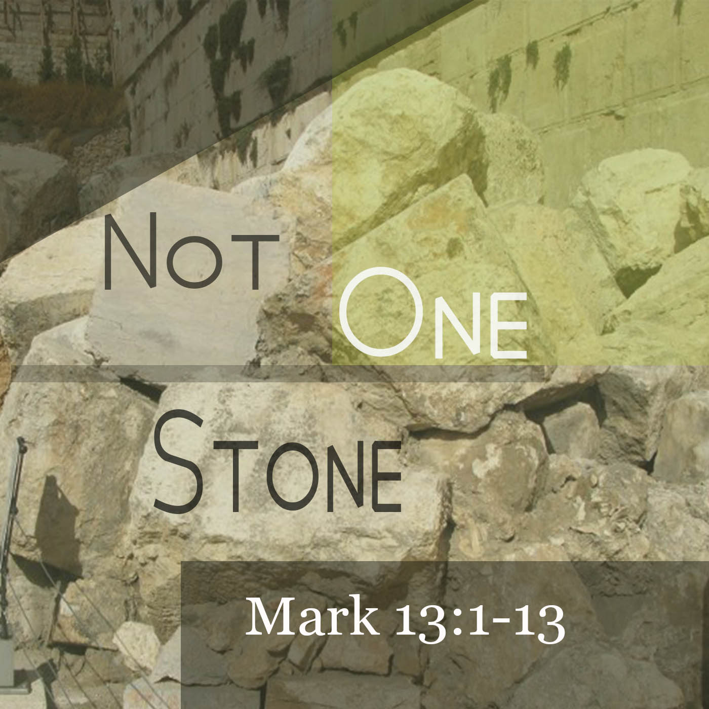

1405 Melvin St, Tallahassee, FL 32301
Phone: (850) 681-0844
Office Hours: Monday to Friday
8:00 am – 4:00 pm
Email: office@stmichaelandallangels.org
Website: www.stmichaelandallangels.org
Find us on Facebook as well!
Follow us on Twitter @SMAA_Tally

From the Rector’s Desk
Giving Thanks
On Thursday, we will celebrate as a nation and a people -Thanksgiving Day. Traditionally, we gather with family and friends to eat a sumptuous meal, but more importantly to reflect on God’s goodness to us His people. I always ask congregations where I have privilege of serving, to share part of that meal with someone who has no family or will not get an invitation, just so they are part of the celebrations of Thanksgiving Day. I think we all can do that. Blessings. Fr. Hugh+
Second Collection
A Second collection will be received next Sunday on behalf of the Legacy School of Performing Arts Training Institute, whose founding Executive & Artistic Director is our own Rasheen Jamison-Richardson. Because of Hurricane Michael, the building used for this program suffered severe damage. Do give generously.
Advent Season
My intention is to do a teaching series during the Advent Season as a way of reminding us all of what we believe and teach in the Episcopal Church. Hopefully, this will be helpful to those who have begun to visit with us in recent times and perhaps want to know more about our Episcopal faith.
Liturgical Changes
To the best of my knowledge, there is no liturgical reason why we should stand for the recital of the psalms – it is our practice to do so for the reading of the gospel. The aforementioned will be phased out. With respect to the weekday celebration of the Eucharist, a contemplative form will be added, where instead of using the readings appointed for the day, we shall read from a non-scriptural writing such as the Presiding Bishop’s book.
Episcopal Visits for 2019
As a parish we are not scheduled to have an Episcopal visit in 2019. However, Vicky A. Haskew, Executive Assistant to the Bishop, has informed us that if we have candidates for Confirmation, Reaffirmation or Reception, we are to inform her, so something can be specially arranged.
Riley Museum Rock-a-Thon
This family friendly activity is scheduled for Saturday, December 1, 2018 at the Cascades Park Amphitheater beginning at 9:00 am and concluding at 3:00 pm. The organizers are hoping to raise a minimum of $30,000 to help off set expenses for mainteance, operations, educational and commuity outreach programs. Let me encourage you to support this effort by making a personal donation. A sign up sheet is in theParish Hall..
-1-
SPECIAL PRAYERS
Father, you have made all people with eyes to see you at work in the world, ears to hear you cry out when right suffers wrong, when justice is brought low. Give to the people of our nation courage to stand up for goodness and right-doing in the face of an oppressive spirit, and courage to believe we may restore, in accordance with your gracious will, a light to enlighten the nations and the people with your truth; through Jesus Christ our Lord, who lives and reigns with you and the Holy Spirit, one God, forever and ever. Amen.

Prayer for the Hurricane Season
Almighty and everlasting God, Lord of Heaven and Earth: Grant unto us thy suppliant people, protection against hurricanes, earthquakes, and other calamities; that in tranquility of weather we may rejoice in the comfort we desire and may always make right use of thy bountiful goodness: through Jesus Christ our Lord. Amen.
THANK YOU – Our Hospitality Committee has prepared a Lite Fare for today’s fellowship. All are welcome.
ANNOUNCEMENTS
THANKSGIVING BASKETS WILL BE DISTRIBUTED TODAY.
African-American Genealogy Meeting today from 2:30 – 4 pm in the Parrish Hall.
November 20 – Said Mass at 12:15 in the Parish Hall.
November 22 & 23 – Office closed for Thanksgiving Holidays.
SPIRITUAL DEVELOPMENT – Bible Study Group meets Wednesdays at 6:00 pm. in the Brooks Room. The readings for this Wednesday will be 2 Samuel 23:1-7, Revelation 1:4b-8 and John 18:33-37
GOOD NEWS OUTREACH MINISTRY –. The Area Agency on Aging is asking for donations to help seniors affected by Hurricane Michael. They are in need of adult incontinent supplies - disposable pads, baby wipes, rash guard cream/ointment, nutrition drinks such as Boost and Ensure, flashlights/batteries, water, hygiene products, towels, etc. Many communities may not have power for many weeks or longer so non-perishables of any sort are welcome. Good News Outreach will be collecting items at the administrative office 347 Office Plaza Drive for Area Agency on Aging. Thank you in advance for any assistance.

CHOIR NEWS – There will be rehearsal every Sunday morning at 9:15 am until further notice.
-6-
Serving today Sunday, November 18
Acolytes: Chalice Bearers: James Fort, Zollie White
Hollis Sams, Crucifer Lectors: Abigail Erefah, Hollis Sams,
Tyler Sams, Torch Bearer Thomas Payne, Tyler Sams
Nicolette Nottage, Torch Bearer Greeters: Akachi Anwuri, Charlie Clark
Omar Mongerie, Gospel Book Bearer Ushers: Lauren Sapp, Linda Billups
Vestry: Ama Erefah
Organist: Monique Alleyne
Serving next Sunday, November 25
Acolytes: Chalice Bearers: Pro Hruda, John Grayson
Pro Hruda, Crucifer Lectors: Alexis McMillan, Laureate Scott
Charles Hruda, Torch Bearer Yolanda Bogan
Quinton Laurie, Torch Bearer Greeters: Elizabeth Humes, Sharal Jugger
Collin Laurie, Book Bearer Ushers: Elizabeth Humes, Sharal Jugger
Vestry: Dawn Freeman
Organist: Monique Alleyne

November Altar Guild
Cassandra Grayson Karen Goodlett Lauren Sapp
Delois Brown Shonna Laurie Anna White
Delores Grayson
PRAYER REQUESTS FOR PEACE AND HEALING
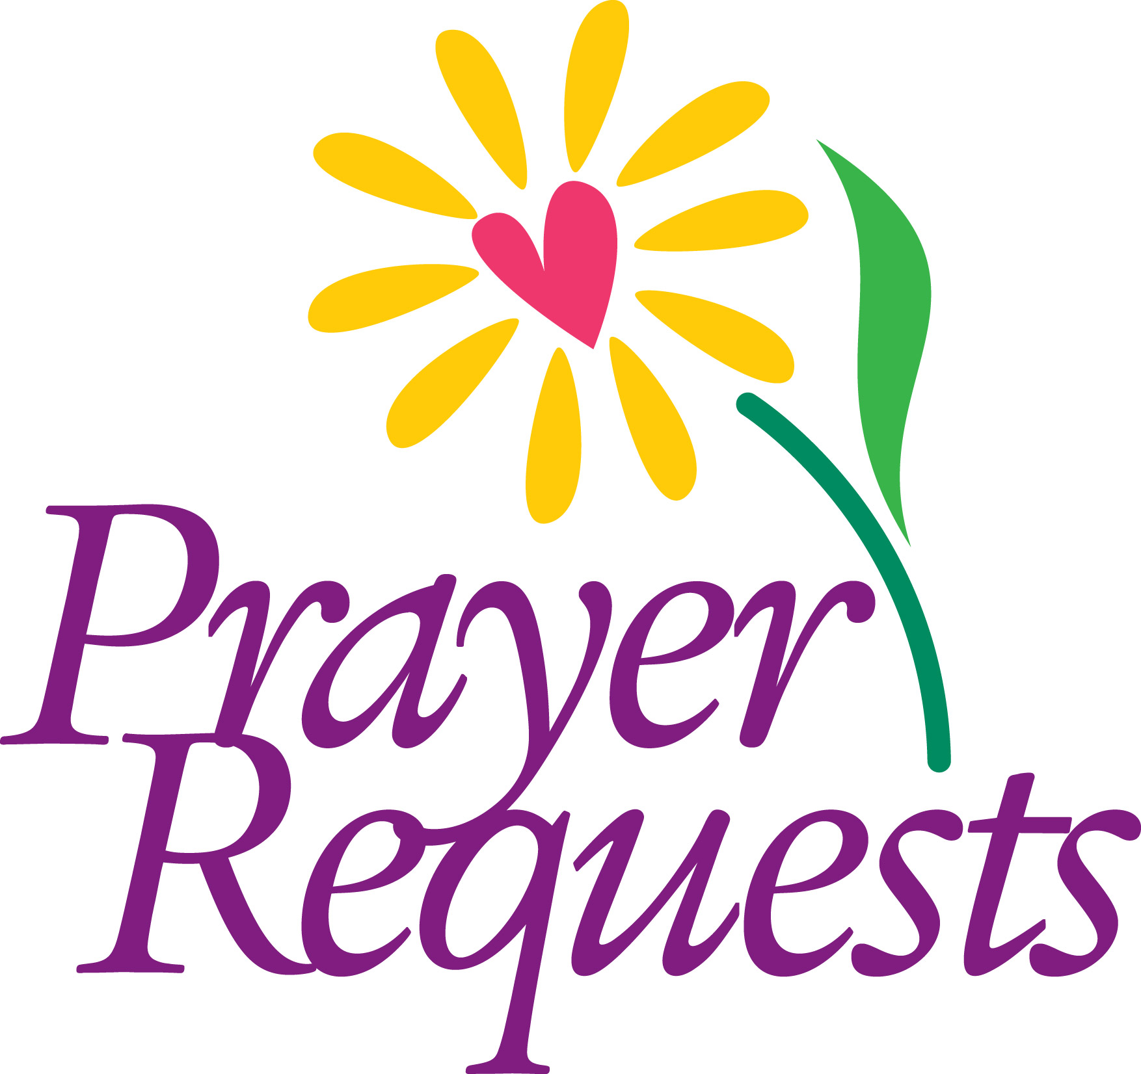
Jean Hyche-Jackson, Dourest and Jo Ann Robinson, Ophelia and Robert Scarbough, Eugene Wesley, Rosalyn Greene, Rose Douglas, Jewell Robinson, Williemae Jackson, Geraldine Roberts, Joseph Wiley, Carl Murray, Rudolph Hinds, Cynthia Hinds, Alexes Parker, Robert Roulac, Karen Hardy Clark, Ella Woodbury, Charles Daniels, Joseph Gentle, Brandi Leland, Kenrick Baynes, Jessie Laurel, Hattie Olivia Scott, Rev. Canon Dr. David J. Weidner, Ella Brown Albright, Catherine Rand, Richard Corpening, Clifford Willabus, David Johnson, Mecie White, Barbara Lee, Sharon Carr, Sam Oliver Sr., Linzie Bogan II, Clark Bogan, Dr. Derek Spencer, Ariel Boyd, Lora Rose Hunter-Dargan, Anita Bush, Thelma Hilliard, John McClees, Jonecia Brown, Louis Chapman, Toni Jarmon, Kaleb Way ,Karen Padmore, Charles Bennett Annette Dwyer, Randolph Frazier Jr., Nohemy Reid and Kanesha Cole.

-5-
HOLY EUCHARIST- RITE TWO
Instrumental Prelude Monique Alleyne, Organist
Choral Prelude
Opening Prayer
We give you thanks, most gracious God, for the beauty of earth and sky and sea; for the richness of mountains, plains, and rivers; for the songs of birds and the loveliness of flowers. We praise you for these good gifts, and pray that we may safeguard them for our posterity. Grant that we may continue to grow in our grateful enjoyment of your abundant creation, to the honor and glory of your Name, now and for ever. Amen.

Processional Hymn A106, In the Beauty of Holiness Lester
THE WORD OF GOD
Opening Acclamation 355
The Collect of the Purity
Gloria
Collect for the Day
The Lessons 1 Samuel 1:4-20
Psalm 16
Hebrews 10:11-14, [15-18], 19-25
Gradual Hymn A160 v 1-2, The Lord is My Light Bouknight
The Holy Gospel Mark 13:1-8 The Reverend Fr Hugh Chapman
Sequence Hymn A160 v 3
Sermon The Reverend Fr. Hugh Chapman
The Nicene Creed 358
The Prayers of the People Form I 383
Confession of Sin and Absolution 360
The Peace May The Peace Of The Lord Nolan
May the peace of the Lord bring: Joy, Love, Comfort, Hope, Rest, Life
May the peace of the Lord surround you. May the peace of the Lord go with you
Blessing of Thanksgiving Baskets and Plaque
Offertory
Doxology & Procession L56, Praise God from Whom all Blessing Flow Hatton
Presentation of the Offering – prayer to be said
Father, we offer you these gifts which you have given us; this bread, this wine, this money. With them we offer ourselves, our lives, and our work, to become through your Holy Spirit, a reasonable, holy and lively sacrifice. As this bread and wine become the Body and Blood of Christ, so may we and all your people become channels of your love; through the same Christ our Lord. Amen.
-2-
Presentation Hymn L65, Bless the Lord Crouch
The Great Thanksgiving 361
Sanctus
The Lord’s Prayer
The Breaking of the Bread 364
Fraction Anthem
The Invitation
Holy Communion
Communion Hymn 1 A451, I Need Thee Every Hour Need
Communion Hymn 2 A442, Sweet Hour of Prayer Sweet Hour
Meditation Hymn A461, Give Me A Clean Heart Douroux
Post Communion Prayer 366
Birthday, Anniversary, Travel Prayers
Announcements
Address by Colton Wasson
Benediction
Recessional Hymn A590, We’re Marching to Zion Marching to Zion
Choral Postlude
Dismissal
A=African American Hymnal (ivory)
L=Lift Every Voice & Sing Hymnal (black, green, red)
From the ECW
Election of Officers – The terms of last year’s officers have come to an end and the newly Nominating Committee comprising of Sharal Jugger, Edith Onyeozili and Genevieve Chapman will be soliciting members for the new ECW Board Members for President, Financial Secretary and Recording Secretary for the 2019 Calendar Year. Please search your hearts and volunteer. Without you there is NO ECW!
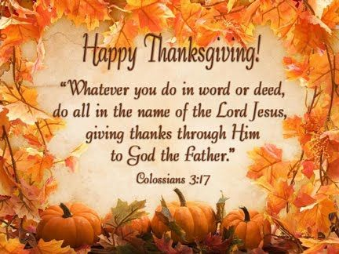
. -3-
WELCOME TO ST. MICHAEL

We extend a warm welcome to our guests. Thank you for worshipping with us today. If you are without a church home, we invite you to join our church family. Please sign the guest register, include your home address, phone number and, if you would like to receive the monthly newsletter, news of special events and other happenings, please also add your e-mail address.
OUR VISION is to be a cornerstone for serving the spiritual needs of the greater Tallahassee community, extending an eternal invitation to join our caring parish and to enrich the spiritual life of all people as we journey with Christ.
OUR MISSION is to experience the Gospel of Jesus Christ by feeding the mind, body and spirit of our community in fellowship and service.
HOLY COMMUNION: All baptized Christians are encouraged to receive the real and living presence of Christ in Holy Communion. To receive the Bread, extend your hands upward, palms crossed. When receiving the Wine, please guide the chalice as it is offered. If you prefer, you may leave the Bread on your palm for the person administering the chalice to dip into the Wine and place on your tongue. All persons are welcome to give thanks for God’s blessings at the altar rail, simply crossing your arms at the wrist with fingertips extending upward towards your shoulders.
HAPPY BIRTHDAY/ANNIVERSARY TO OUR CHURCH FAMILY!
Melanie Martin (11/24), Monique Alleyne (11/24)

Birthday Prayer
Watch over thy children, O Lord, as their days increase; bless and guide them wherever they may be. Strengthen them when they stand; comfort them when discouraged or sorrowful; raise them up if they fall; and in their hearts may thy peace, which passeth understanding, abide all the days of their lives; through Jesus Christ our Lord. Amen.
2019 Church Kalendars
The 2019 church kalendars have arrived and may be purchased for $6 each from any altar Guild member.

-4-

